Case 3-Asia-Indus-Figurine-Female-Solid Terra Cotta-3300-1300 BCE

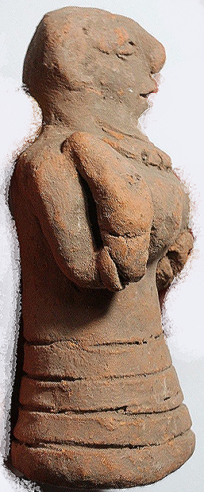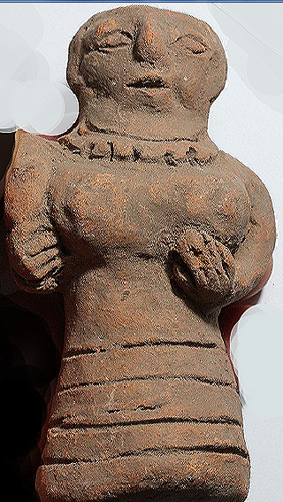 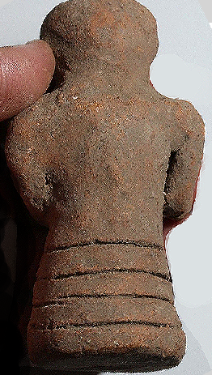 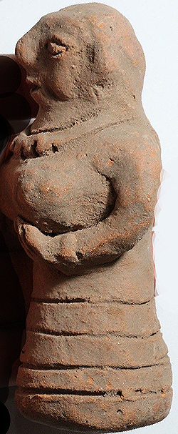 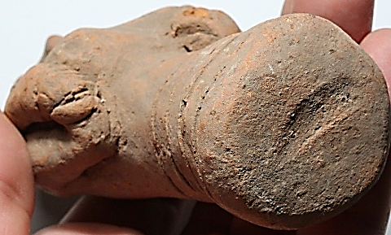

Asia-Indus-Figurine Female-Solid Terra Cotta-3300-1300 BCE

**Case no.: 3**

**Accession Number:**

**Formal Label:** Asia-Indus-Figurine Female-Solid Terra Cotta-3300-1300 BCE

**Display Description:**

**This** Indus-Female Figurine has a Solid Terra Cotta core. She resembles many of the pillar figurines except or the solid core. She holds a torch in her right hand and her left arm is situated under her left breast. The torch signifies she is a priestess leading others in a nocturnal ceremony.

**LC Classification:**

**Date or Time Horizon:**

**Geographical Area:**

**Map:**

**GPS coordinates:**

**Cultural Affiliation:**

**Media:**

**Dimensions:**

**Weight:**

**Condition:**

**Provenance:**

**Discussion:**

**References:**